Software Requirement Specifications
Car Rental Management System



Submitted by
Muhammad Sameer (S25BINFT7M04040)

Submitted to
Dr.Syed Ali Nawaz Shah

Department of Information Technology
Faculty of Computing
The Islamia University of Bahawalpur

Meeting Details
Sr No | Details | Date | Supervisor Signature
Summary
This project is a web-based Car Rental Management System designed to simplify the process of renting cars online. The system allows users to create accounts, search for available cars in real time, and make bookings based on date, time, and location. It also provides secure online payment, booking management, GPS tracking, and user feedback features. On the admin side, the system helps manage users, vehicles, and bookings efficiently. The system improves convenience, reduces manual work, and enhances customer experience.

Table of Contents
- Introduction
1.1 Purpose
1.2 Scope
1.3 Product Perspective
1.4 User Characteristics
1.5 Similar Apps and Systems / Literature Review
1.6 Proposed Technologies
- Requirements
2.1 Functional Requirements
2.1.1 User Registration (Sign Up)
2.1.2 Login
2.1.3 Search Cars
2.1.4 View Car Availability
2.1.5 Book Car
2.1.6 Online Payment
2.1.7 Manage Booking (Modify/Cancel)
2.1.8 GPS Tracking
2.1.9 Reviews and Ratings
2.1.10 Notifications
2.1.11 Admin Management
2.2 Non-Functional Requirements
2.2.1 Performance
2.2.2 Security
2.2.3 Usability
2.2.4 Reliability
2.2.5 Scalability
2.2.6 Maintainability
- Use Cases and Flow of Processes
3.1 System Use Case Diagram
3.2 Use Case Description (Book Car)
3.3 Activity Diagram
- References

- Introduction

The Car Rental Management System is developed to automate and digitalize the traditional car rental process. It provides an online platform where customers can easily search, book, and manage rental cars without visiting a physical office.
  - Purpose
The purpose of this system is to:
- Provide an easy online car booking system
- Reduce manual work for rental businesses
- Improve customer experience with real-time services
  - Scope
Included:
- User registration and login
- Car search based on location, date, and time
- Online booking and payment
- Booking modification and cancellation
- GPS tracking system
- Reviews and ratings
- Admin management system
Not Included:
- Physical car maintenance system
- Third-party insurance processing
  - Product Perspective

This is a standalone web-based system that can be accessed via browser. It may later integrate with mobile apps and external payment gateways.
  - User Characteristics
- Customer: Basic knowledge of internet usage
- Admin: Technical knowledge to manage system
- Guest User: Can browse but cannot book
  - Similar apps and systems/Literature Review
- Uber Rentals
- Careem
- Local car rental websites
Limitations in existing systems:
- Limited real-time availability
- Poor user interface
- Lack of proper booking management
  - Proposed Technologies
- Frontend: HTML, CSS, JavaScript
- Backend: PHP / Node.js
- Database: MySQL
- GPS Integration: Google Maps API
- Requirements

The system provides features like user management, car booking, real-time availability checking, payment processing, and admin control panel.
  - Function Requirements
Authors will provide definite number of functional requirements in standard format. These requirements directly in the with functions which are already provided. The requirement format as following.
    - Sign Up
- Name: FR001
- Purpose: To allow users to create an account
- User(s): Customer
- Input: Name, Email, Password, Phone
- Output: User account created successfully
  - Non-Functional Requirements
• Performance: Fast response time
• Security: Secure login and payment system
• Usability: User-friendly interface
• Reliability: System available 24/7
• Scalability: Can handle increasing users
• Maintainability: Easy to update system
- Use Cases and Flow of Processes
Use cases are the formal representation of process flow defined by functional requirements. Authors should provide a flow of events in this. There should be system level use case which is directly influenced to project functions with their user(s) (called actor(s)) which are described in requirements chapters
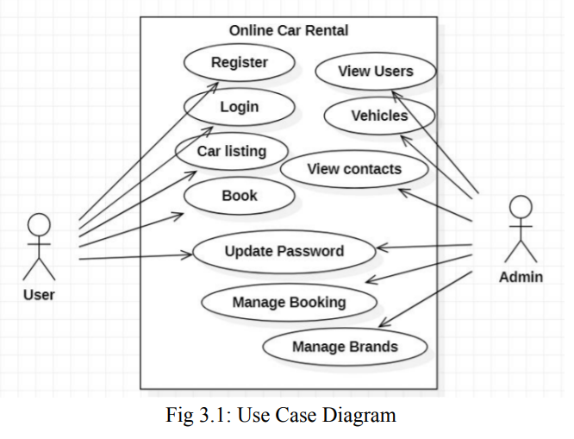
  - Use Case 1
ID | UC001
Name | Sign Up
Description | This use case describes the process flow of Sing Up
Requirement(s) | FR001
Actor(s) | Admin, Data Entry, Operator
Precondition | Actors must not be member of Hospital
Postcondition | Actors will view the message for approval from admin
Basic Flow | Basic Flow  - Actor enter credentials  - System validates the inputs  - Following fields are required  - Name  - Email  - Password  - Address  - Phone  - Check the proper inputs for following  - Email  - Password must be 8 character including number  - Phone Number on 11 digits  - On successful validation the system will create new user  Alternative Flow  - Admin Sign In  - Create a new User by entering data  Exceptions  - Invalid Inputs  - System unable to response
Diagrams:
Author should provide the Activity diagram of each Use case. If required then sequence diagrams also add to this section.
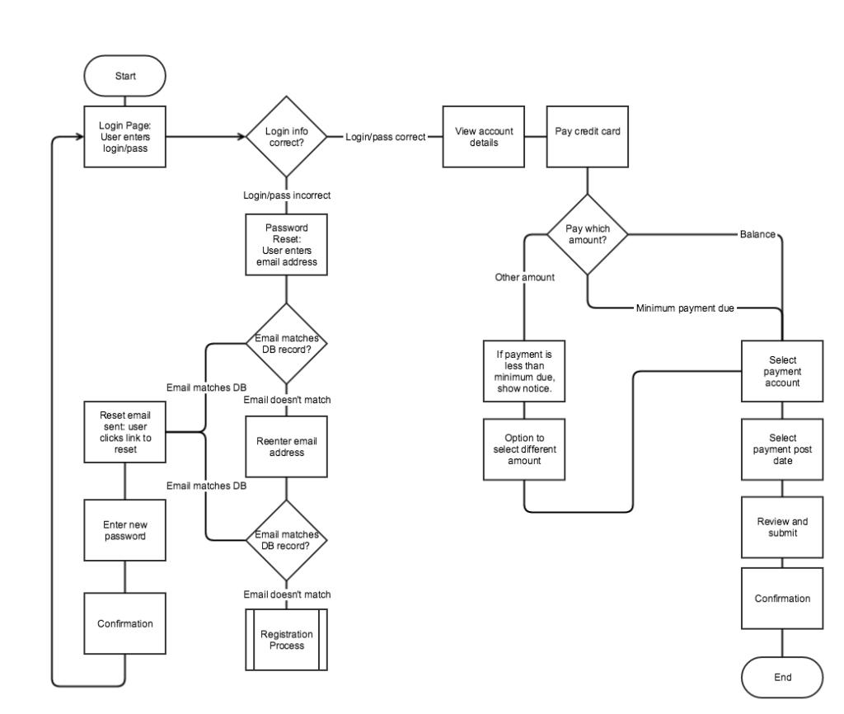
- References
- IEEE SRS Documentation Standards
- Online Car Rental Systems (Uber, Careem)

